NAME: _______________________________

TEACHER: ___________________________

YEAR 12 CHEMISTRY

3ACHE TASK 7

Practical Report Quiz

TIME: 1 HOUR

MARKS: 25

Percentage Purity and the Ideal Gas Law (7 marks)

A group of students performed this same experiment using a 2.5 cm length of aluminium metal suspended in a copper coil. The students weighed a 50 cm length of aluminium, and found it had a mass of 0.7425 g.

After complete reaction with the excess hydrochloric acid, gas was collected that had a volume of 48.2 mL which was adjusted to the atmospheric pressure of 103.6 kPa and measured at 28 ºC. The partial pressure of water at this temperature is 3.78 kPa.

Calculate the percentage purity of the aluminium. (7)

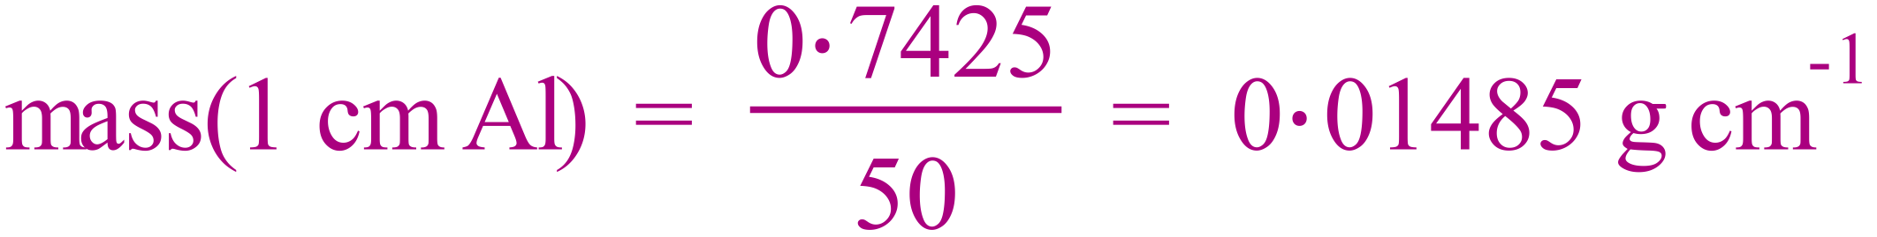

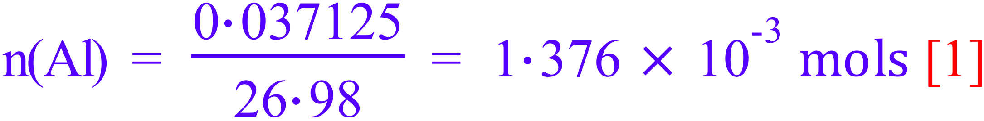

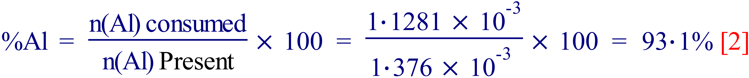

Le Chatelier’s Principle and gases (5½ marks)

a) Write the equation for the equilibrium reaction between nitrogen dioxide and dinitrogen tetroxide, both in the gaseous state. (½)

b) What colour is nitrogen dioxide? (½)

Brown

c) What colour is dinitrogen tetroxide? (½)

Colourless

d) What colour is a mixture of the two gases? (½)

Pale Brown

a) What precisely is observed when a mixture of the two gases is instantaneously compressed to half its volume? (½)

Becomes darker

b) What is observed during the next few seconds? (½)

Becomes lighter

c) Use Le Chatelier’s principle to explain this second observation. (1)

The equilibrium shifts to favour the side with the lower molar gas ratio (forward) to reduce the imposed change ( increased pressure)

3.

- What is observed when a mixture of the two gases at room temperature is placed in a hot water bath at 100 ºC ? (½)

The colour becomes darker

- Use Le Chatelier’s principle to explain this observation. (1)

The equilibrium shifts to favour the reaction which absorbs energy (reverse) to reduce the imposed change (increased temp).

Le Chatelier’s Principle and solutions (4½ marks)

One equation for the equilibrium reaction between chromate ion and dichromate ion in the aqueous state is:

2 CrO₄²⁻_{(aq)} + 2 H⁺_{(aq)} ↔ Cr₂O₇²⁻_{(aq)} + H₂O_{(l)}

(yellow) (orange)

A solution is prepared by adding equal volumes of 0.05molL⁻¹ potassium chromate and 0.05molL⁻¹

potassium dichromate.

a) What is the colour of this mixture? (½)

Pale orange

The solution is split into three equal portions and to each portion is added one of the following chemicals.

Portion A: Add excess 0.2 molL⁻¹ hydrochloric acid.

b) In which direction (forward or reverse) is the equilibrium shifted? (½)

Forward

c) What colour is the final solution, compared to the original? (½)

more orange

Portion B: Add excess 0.2 molL⁻¹ sodium hydroxide.

d) In which direction (forward or reverse) is the equilibrium shifted? (½)

Reverse

e) What colour is the final solution, compared to the original? (½)

More yellow

Portion C: Add a large quantity of water.

f) In which direction (forward or reverse) is the equilibrium shifted? (½)

Reverse

g) What colour is the final solution, compared to the original? (½)
more yellow

Consider the following system:

Co(H₂O)₆²⁺_{(aq)} + 4Cl ⁻¹_{(aq)} ↔ CoCl₄²⁻_{(aq)} + 6H₂O_{(l)}
(pink) (deep blue)

If a solution of silver nitrate is added to the system:

a) In which direction (forward or reverse) is the equilibrium shifted? (½)

Reverse

b) What colour is the final solution? (½)

Pink

Solubilities of nitrates, chlorides, sulfates and carbonates of some common cations.
(8 marks)
- Fill in the following table with the colour of the precipitate or write “N.R.” (no reaction) if there is no precipitate formed. (6)

Solution | NaNO₃ | NaCl | Na₂SO₄ | Na₂CO₃
AgNO₃ | NR | White | NR/white | Yellow
FeCl₃ | NR | NR | NR | Pale brown
BaCl₂ | NR | NR | White | White

2. What is the general rule for solubility of chlorides? (½)

Generally soluble except for Silver chloride and lead chloride

- Write balanced ionic equations, including states for the reaction between:

a) lead (II) nitrate solution and sodium chloride solution. (½)

b) iron (III) chloride solution and sodium carbonate solution. (½)

- Why is it important to wash out the plate or test tube before using it for another test? (½)

To avoid contamination.

END OF TEST

